# WP SEA 248

# ICES/NAFO/NAMMCO WORKING GROUP ON HARP AND HOODED SEALS

IMR, TROMSØ, NORWAY, 2-6 SEPTEMBER 2019

The 2019 abundance of hooded seals (*Cystophora cristata*) in the Greenland Sea

Martin Biuw1, Tore Haug1, Tor Arne Øigård2

1Norwegian Computing Centre, P.O. Box 114 Blindern, NO-0314 Oslo, Norway

2Institute of Marine Research, Fram Centre, P.O. Box 6606 Langnes, NO-9296 Tromsø, Norway

# ABSTRACT

Historical records of fecundity rates on mature female hooded seals in the Greenland Sea are very sparse. In previous work (Øigård and Haug, 2016a) the population dynamics model was therefore run for a range of fecundity rates. It was determined that a fecundity rate of 0.7 was realistic for this population. While we present estimates for the same range of fecunduty as in Øigård and Haug (2016a), we consider the model with a fecundity rate of 0.7 to be the most robust ad realistic. In agreement with previous model runs, our results indicated a substantial decrease in the Greenland Sea hooded seal population abundance from the late 1940s and up to the early 1980s. After 1980, the population size appears to be relatively stable at a low level. Including the new estimate of pup production obtained in 2018, a 2019 abundance of 64 267.28 1+ animals (49 935 – 78 600) and 12 944 (9 821 – 16 068) pups were estimated. The total 2019 population of hooded seals in the Greenland Sea therefore was estimated to 76 623 (58 299 – 94 947) seals of all ages. Even when assuming no catch, the model predictions indicated a decrease in the 1+ population of about 13% (SD:14%) over the next 15 years. The 2019 population of hooded seals in the Greenland Sea was about 6.7% of $N_{max}$, which is well below $N_{lim}$ (30% of $N_{max}$). Following the Precautionary harvest strategy previously developed by WGHARP (see ICES, 2006a, 2006b), the implication of the population being below $N_{lim}$ is that no catch from the population is advised.

# INTRODUCTION

The total population size of hooded seals in the Greenland Sea is estimated using a deterministic age-structured population dynamics model which makes use of historical catch records, fecundity rates, age specific proportions of mature females, and estimates of pup production to estimate the population size trajectory (ICES, 2011). Prior to 2011, the model that was used to assess the Northeast Atlantic hooded seal population assumed a constant maturity ogive and pregnancy rate over the entire time period over which the model was run. At the 2011 meeting of WGHARP, the traditional model was modified to allow for non-constant maturity ogives and pregnancy rates in order to utilize all historical data available (ICES, 2011). The model also allowed the estimates obtained to be projected into a future population size for which statistical uncertainty is provided for several relevant harvest options. While the historical data on fecundity rates available for the Greenland Sea hooded seal population is very sparse, all observed rates are around 0.7 (ICES, 2016). Because of this, the most recent model run (ICES, 2016) used a fixed fecundity rate of F = 0.7 for all years.

# MATERIALS & METHODS

## Reproductive rates

Maturity curves were constructed based on female reproductive material collected over the period 1990-94 and 2008-10 (ICES, 2011). The record of historical fecundity rate is sparse, but previous analyses have indicated that fecundity rates remained constant around F = 0.7 during the period 1958 – 1999 (ICES, 2013). This is lower than the estimate of F = 0.9 used by the WG in 2011 (ICES, 2011). Øigård and Haug (2016a) ran the population model for a range of fecundity rates, and found that while they resulted in relatively large variations in historical population sizes, the effects were non-significant in terms of estimated population sizes in recent decades. While we present estimates for all fecundity rates evaluated by Øigård and Haug (2016a), we propose the model that was run using F = 0.7 to be considered when providing assessment and advice. This is in accordance with what was done for the most recent assessments (ICES, 2016).

## Survey pup production estimates and catch history

Pup production estimates are available from aerial surveys conducted in 1997, 2005, 2007, 2012 2018 (Table 2, ICES, 1998, 2011; Salberg *et al.*, 2008; Øigård *et al.*, 2014; Biuw *et al.*, 2019). Catch levels for the period 1946 – 2019 are presented in ICES (2016) and Haug. *et al.* (2019).

## The population model

The population model used to assess the abundance for the Greenland Sea hooded seal population is a deterministic age-structured population dynamics model. It uses historical catch records, fecundity rates, age specific proportions of mature females, and estimates of pup production to estimate the population trajectory. The model is similar to the models used to assess the abundance of the Greenland Sea harp seal population and the Barents Sea / White Sea harp seal population (ICES, 2013; Øigård and Haug, 2016b).

# RESULTS & DISCUSSION

## Population estimates

The estimated population, along with the parameters for the normal priors used are presented in Table 3. The mean of the prior for $M_{0}$ was taken to be three times that of the mean of $M_{1+}$. The population size and pup production trajectories are shown in Figure 1. All model runs indicates a substantial decrease in the population abundance from the late 1940s until the early 1980s. In the two most recent decades, the population size appears to have been stable at a low level, or decreased slowly. Using a fecundity rate of F = 0.7, we estimated a 2019 abundance of 64 267.28 1+ animals (49 935 – 78 600) and 12 944 (9 821 – 16 068) pups. The total 2019 population of hooded seals in the Greenland Sea therefore is estimated to 76 623 (58 299 – 94 947) seals of all ages. For comparison, the total population size of hooded seals in the Greenland Sea was estimated to 85 790 seals in 2011 (ICES, 2011), 82 830 seals in 2013 (ICES, 2013), and 80 460 in 2017 (ICES, 2016).

## Catch options

Since the only available fecundity rates are based on data from the 1990s, the Greenland Sea hooded seals should be regarded as data poor. The impacts of the catch scenarios are explored over a 15 years period. Summary of requested options for various catch scenarios of hooded seals in the Greenland Sea are:

1. Current catch level (average of the catches in the period 2015 – 2019).
2. Equilibrium catches.
3. Catches that would reduce the population to N70 with probability 0.8 over a 15-years period.

Current catch level is defined as the average catch level of the last 5 years, i.e., the average catch level of the period 2015 – 2019. Due to the low pup production numbers the Greenland Sea hooded seal population has been protected since 2007 (ICES, 2006b, 2013, 2016). While there is no commercial hunt on hooded seals in the Greenland Sea, there is a small scientific hunt. The equilibrium catch level is defined as the (fixed) annual catch level that stabilizes the future 1+ population under the estimated model. As the model predicts a decline of the population size even for no catch, and that the total abundance is way below $N_{lim}$, the catch options for equilibrium catch level, and the catch level that would reduce the population to $N_{70}$ with probability 0.8 over a 15 year period is not applicable.

At current catch levels, and using a fecundity rate F = 0.7, the model indicates a 13% (SD:14%) decrease of the 1+ population over the next 15 years. Note however, that the confidence intervals for the depletion coefficient are quite wide.

The 2019 population of hooded seals in the Greenland Sea remains way below $N_{lim}$ (30% of $N_{max}$). Following the Precautionary harvest strategy previously developed by WGHARP (see ICES, 2006a, 2006b), the implication of the population being below $N_{lim}$ is that no catch from the population is advised.

# REFERENCES

Biuw, M., Øigård, T. A., Nilssen, K. T., Stenson, G., and Haug, T. 2019. Estimation of pup production of harp and hooded seals in the Greenland Sea in 2018.

Haug., T., Biuw, M., and Zabavnikov, V. 2019. Norwegian and Russian catches of harp and hooded seals in the Northeast Atlantic in 2017-19.

ICES. 1998. Report of the Joint ICES/NAFO Working Group on Harp and Hooded Seals, 28 Aug- 3.Sept 1997, ICES Headquarters, Copenhagen.: 35 pp.

ICES. 2006a. Report of the Joint ICES/NAFO Working Group on Harp and Hooded Seals (WGHARP), 30 Aug-3 Sept. 2005, St.Johns, Newfoundland, Canada.: 48 pp.

ICES. 2006b. Report of the Joint ICES/NAFO Working Group on Harp and Hooded Seals (WGHARP), 12-16 June. 2006, ICES Headquarters, Copenhagen, Denmark.: 28 pp.

ICES. 2011. ICES WGHARP REPORT 2011 Report of the Working Group on Harp and Hooded Seals ( WGHARP ), 15-19 Aug, 2011, St Andrews, Scotland.: 15–19. St Andrews, Scotland. [http://www.ices.dk/sites/pub/Publication Reports/Expert Group Report/acom/2011/WGHARP/WGHARP 2011.pdf](http://www.ices.dk/sites/pub/Publication%20Reports/Expert%20Group%20Report/acom/2011/WGHARP/WGHARP%202011.pdf).

ICES. 2013. Report of the Joint ICES/NAFO Working Group on Harp and Hooded Seals (WGHARP), 30 Aug-3 Sept. 2005, St.Johns, Newfoundland, Canada.: 48 pp.

ICES. 2016. Report of the Joint ICES/NAFO Working Group on Harp and Hooded Seals (WGHARP), 26-30 Sept. 2016, ICES Headquarters, Copenhagen, Denmark.: 85 pp.

Salberg, A. B., Haug, T., and Nilssen, K. T. 2008. Estimation of hooded seal ( Cystophora cristata ) pup production in the Greenland Sea pack ice during the 2005 whelping season. Polar Biol., 31: 867–878.

Øigård, T. A., Haug, T., and Nilssen, K. T. 2014. Current status of hooded seals in the Greenland Sea. Victims of climate change and predation? Biol. Cons., 172: 29–36.

Øigård, T. A., and Haug, T. 2016a. The 2017 abundance of Hooded Seals (Cystophora cristata) in the Greenland Sea.

Øigård, T. A., and Haug, T. 2016b. The 2017 abundance of harp seals (Pagophilus groenlandicus) in the Barents Sea / White Sea.

| Table 1. Estimates of proportions of mature females (pi,t). The P1 estimates are from ICES (2008) and the P2 estimates are from ICES (2011). Mature females had at least one Corpus Luteum or Corpus Albicans in the ovaries. | | | | | | | | | | | |
| --- | --- | --- | --- | --- | --- | --- | --- | --- | --- | --- | --- |
| Age | 1y | 2y | 3y | 4y | 5y | 6y | 7y | 8y | 9y | 10y | 11y |
| p1 | 0.00 | 0.05 | 0.27 | 0.54 | 0.75 | 0.87 | 0.93 | 0.97 | 0.98 | 0.99 | 1.00 |
| p2 | 0.00 | 0.00 | 0.06 | 0.60 | 0.89 | 0.97 | 0.99 | 1.00 | 1.00 | 1.00 | 1.00 |

| Table 2. Estimates of Greenland Sea hooded seal pup production, based on data from ICES (1998), ICES (2011), Salberg et al., 2008, Øigård et al., 2014 and Biuw et al. (2019). | | |
| --- | --- | --- |
| Year | Estimated number of pups | CV |
| 1997 | 23 762 | 0.192 |
| 2005 | 15 250 | 0.228 |
| 2007 | 16 140 | 0.133 |
| 2012 | 13 655 | 0.138 |
| 2018 | 12 977 | 0.140 |

| Table 3. Estimated mean values and standard deviations of the parameters used in the current management model for Greenland Sea hooded seals. Estimates are provided for a range of choices of the fecundity rate, F. Priors used were the same as those used in Øigård & Haug (2016b). See text for parameter definitions. | | | | | | |
| --- | --- | --- | --- | --- | --- | --- |
|  | F=0.5 | | F=0.7 | | F=0.9 | |
| Parameter | Mean | SD | Mean | SD | Mean | SD |
| N1946 | 1 304 560 | 356 883 | 1 136 055 | 300 842 | 1 013 514 | 256 437 |
| M0 | 0.33 | 0.22 | 0.34 | 0.22 | 0.34 | 0.22 |
| M1+ | 0.14 | 0.1 | 0.17 | 0.09 | 0.19 | 0.09 |
| N0,2019 | 12 732 | 1 542 | 12 944 | 1 593 | 13 164 | 1 616 |
| N1+,2019 | 79 314 | 8 907 | 64 267 | 7 312 | 55 765 | 6 331 |
| NTotal,2019 | 91 123 | 10 952 | 76 623 | 9 348 | 68 551 | 8 347 |
| D1+ | 0.84 | 0.13 | 0.87 | 0.14 | 0.91 | 0.15 |
| NTotal,2035 | 76 670 | 19 873 | 66 978 | 17 950 | 62 137 | 16 791 |

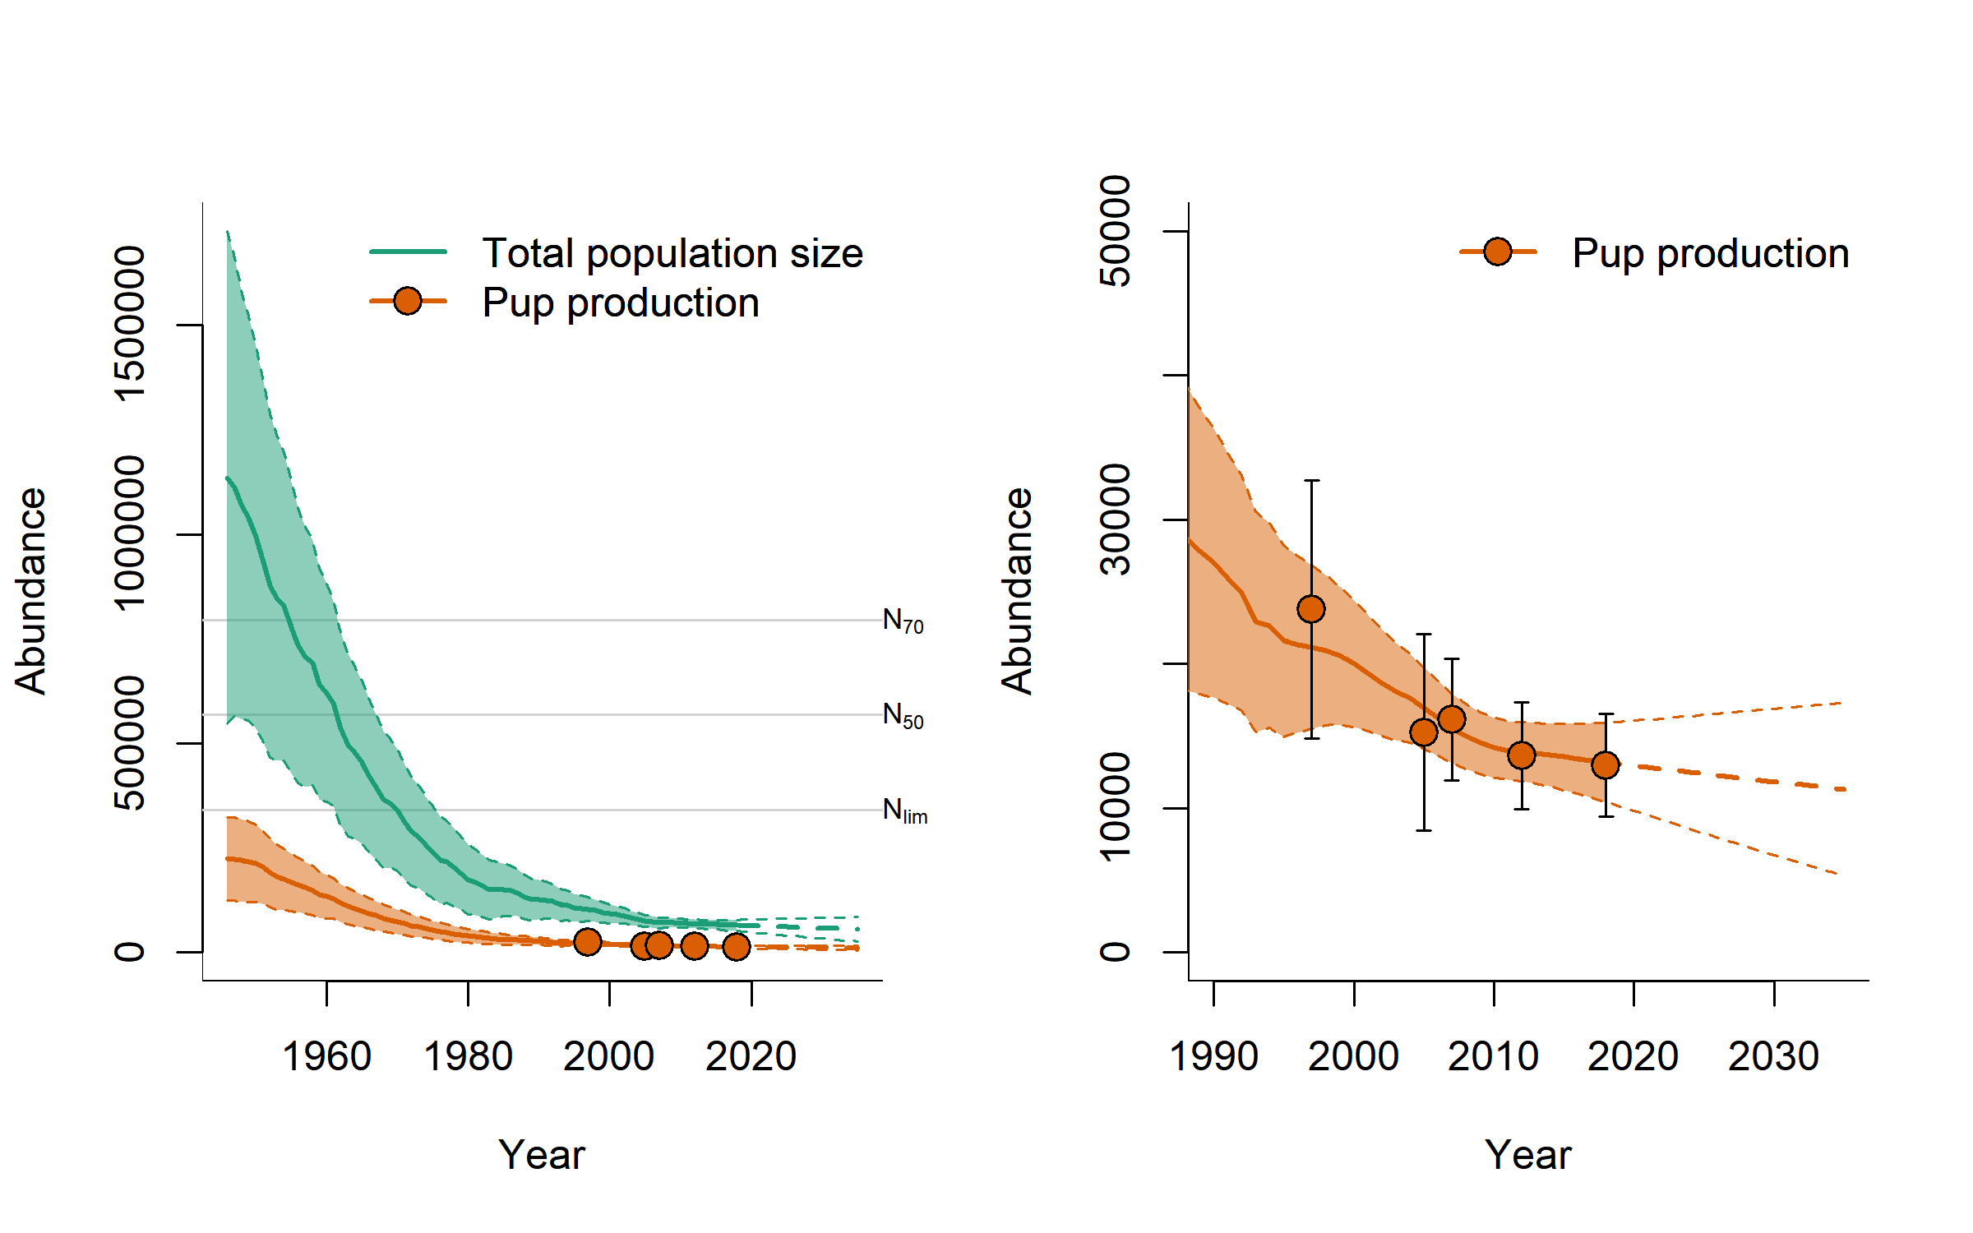

Figure 1: Modelled population trajectories for Greenland Sea hooded seal pups and adults (full lines), 95% confidence intervals (shaded areas) and future projections (dashed lines) for various choices of fecundity rates (F). N70, N50, and Nlim denote the 70%, 50%, and 30% of the historical maximum population size, respectively (obtained from the scenario of a mean fecundity rate of F = 0.7). Observed pup production estimates are indicated by filled circles.